Shabbos Stories for
Parshas PURIM 5777
Volume 8, Issue 28 14 Adar 5777/ March 12, 2017
Printed L’illuy nishmas Nechama bas R’ Noach, a”h

For a free subscription, please forward your request to keren18@juno.com

The Satmar Rebbe and His Donation To an “Undeserving” Recipient
By Rabbi David Bibi

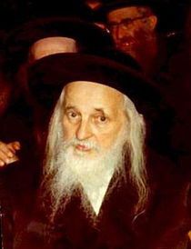

This morning we were discussing the misvah of Matanot LaEvyonim on Purim. which is the distribution of two monetary gifts, one to each of two paupers. One should distribute Matanot La’Evyonim generously and joyfully and fulfills his obligation by giving even a few cents per pauper, nevertheless, it is preferable to spend more on Matanot La’Evyonim then on the Purim feast or Mishloach Manot. One should preferably give enough so that the pauper will be able to make use of the sum for the Purim feast.
Different than the rest of the year where one can investigate one who asks for help, on Purim one is not strict with the poor in determining whether they are needy or not. “Whoever puts out his hand is to be given a gift.”
In this zechut we pray that when we put forth our hand or request to Hashem, that he not turn us away and give us whether we are deserving or not.
I suggested that people tell over the following story from Aleynu LeShabeyach at their Friday night table this evening and ask ourselves how we would react in the same situation? And could we adjust our perspective to at least react differently on Purim?
The Satmar Rebbe was renowned as a magnanimous baal tzedakah, and all of the money that passed through his hands was distributed to the poor on the same day. Once, a pauper came to him and poured out his tale of woe, begging for the Rebbe’s assistance. He cried to the Rebbe that he had lost his Wife, and was left alone to care for his orphaned children. In addition, his leg had been amputated.
The Rebbe gave him a handsome contribution, as he did to everyone who came to him for charity. Several minutes later, the Rebbe’s gabbai entered his chamber, very distraught. “What happened?” the Rebbe asked.
“The pauper who was just here — the one who said that his leg was amputated — is not missing a leg. I saw him leave from here and walk on two feet like a regular person,” the gabbai said indignantly.
When the Rebbe heard this, he rose from his seat, visibly agitated, the gabbai was sure that the Rebbe would tell him to run after the pauper and ask him to return the money he had received from the Rebbe. He was surprised, however, when he heard the Rebbe let out a sigh of relief and say, “What joy your words have brought me‘.
Thank Heaven, the pauper was not lame!”
Several minutes later, the gabbai came into the Rebbe’s chamber once again, this time to inform the Rebbe that the pauper was in fact not a widower raising orphan children on his own. “I saw his wife outside,”
Again the Rebbe expressed his great relief and joy that the man had not been widowed after all.
A Jewish leader desires only good for Hashem’s children.
Now, what would you do? Can hearing this story have an impact on your own behavior? At least on Purim?

Reprinted from the March 3, 2017 Follow up on Shabbat Shalom from Cyberspace for Parashat Terumah 5777.

The Purim Story
By Yaffa Ganz

Is Purim just a fun-filled dress up holiday? Or is it something more? Perhaps it's a flip-flop, upside-down, full of surprises kind of day...not at all what you'd expect.
Over 2,000 years ago, the Holy Temple in Jerusalem was destroyed by the Babylonian king Nebuchadnezzar. The Jewish people were sent away from the Land of Israel and were forced to live in Babylonia.
Fifty years later, Babylonia was defeated by Persia. Achashverosh (that's pronounced: Ah-chash-VEY-rosh) was the second Persian king. He ruled 127 provinces from Hodu (India) to Kush (Africa) the largest, strongest kingdom in the world.
A new king needs a new capital, so Achashverosh chose the city of Shushan. To celebrate, he made a tremendous feast for all the important people in the kingdom. It lasted for 180 days. Then he made a second feast just for Shushan. Everyone in the city was invited, even the Jews.
Mordechai, the leader of the Jews, warned his people not to go to the feast, but they were afraid to disobey the king. And to tell the truth, they were honored and pleased to have been invited. For seven days they ate and drank to their heart's content. Only one thing troubled them. Achashverosh brought the gold and silver vessels from the Holy Temple in Jerusalem and used them for his wild celebration...
The drunken king began to brag that his queen Vashti was the most beautiful woman in the kingdom. On the last day of the feast, he commanded her to come and dance before the crowd. But Vashti was the proud granddaughter of the cruel Nebuchadnezzar and she refused to appear. "Am I a servant to the king?" she asked. In a fit of anger, the king had her killed.
Achashverosh now needed a new queen and he wanted someone even more beautiful than Vashti. His men went from house to house in all of Persia, taking the young girls away to Shushan where they were kept as hostages until they were brought before the king.
In Shushan, a Jewish orphan by the name of Hadassah lived with her uncle Mordechai. When the king's men came to her house, Mordechai said, "Don't be afraid. Go with them. Do not tell them you are a Jewess. Tell them your Persian name -- Esther. God will watch over you!"
Esther was kind and gentle and very beautiful. As soon as the king saw her, he chose her as his new queen. Esther appointed seven maidservants, one for each day of the week, so that she would always remember which day was the Sabbath. Her meals were cooked with kosher foods. And all the while, she kept her secret. No one knew she was a Jew. Everyday, Mordechai sat outside the palace gate to wait for news from Esther.
One day outside the palace, Mordechai happened to hear two men plotting to kill the king. He warned Esther and the two men were caught and killed. Although it was recorded in the Royal Book that Mordechai the Jew had saved the king, the matter was soon forgotten.
Soon after, Achashverosh appointed Haman -- the richest man in the kingdom -- as his new prime minister. All the king's subjects were ordered to honor Haman and bow down to him. Everyone did, except Mordechai. It was permissible to honor Haman and bow to him as the prime minister, but Haman wore a large medallion, engraved with the picture of an idol, on his chest. Mordechai said people might think he was bowing to the idol too, and a Jew is forbidden to worship or honor idols.
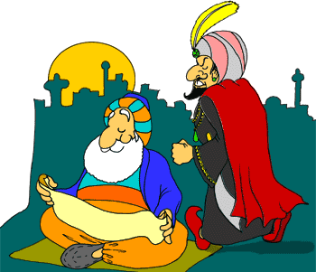
Haman was furious. He went straight to the king to complain. "There is one nation," he said, "scattered throughout your kingdom, which is different from all other nations. They don't eat our food, drink our wine, or marry our daughters! They don't keep the king's laws and they don't work! Every seventh day they rest and they are always celebrating holidays. If you give me permission, I will destroy them for you. I will even pay for any expenses from my own money!"
Achashverosh gave Haman his royal ring, to seal the orders and decrees. Anxious to do a perfect job, Haman wanted to execute his plan on the right day, a lucky day blessed by his gods and the stars. He cast lots -- purim in Hebrew -- to choose the day. Then he sent out letters, sealed with the king's royal ring, to each of the 127 provinces in the kingdom.
"On the 13th day of the month of Adar," the decree said "you are to destroy, kill and slaughter all Jews, young and old, women and children, all in one day. Their money and property will then belong to you."
When Mordechai heard of the decree, he ripped his clothing and put ashes on his head as a sign of mourning. He told Esther she must go to the king to try and save the Jews. Esther was afraid, for it was forbidden to come before the king without being invited. But Mordechai said, "Who knows if you have not been put in the palace for this very purpose? If you are silent now, help will come to the Jews from some other place -- and you will perish!"
Esther asked that the Jews in Shushan fast and pray for her for three days. Mordechai gathered all the Jewish children in Shushan and told them to pray, too. (In the end, it was the prayers of the children which were answered.)
The Jews finally realized they should not have gone to the king's feast; they should not have eaten at the royal banquet nor drunk the wine, nor used the vessels from the Holy Temple. They understood that this was their punishment for fearing the king more than they feared G-d.
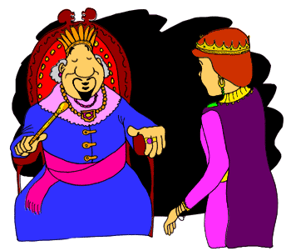

When the three days of prayers and fasting were over, Esther went to the king. "What is your request, my queen?" he asked. "Half of my kingdom is yours for the asking!"
But Esther asked only that the king and Haman come to a private banquet she was making. At the banquet, Achashverosh asked again, "What is your wish? Whatever you want is yours!" But Esther only invited the king and Haman to a second party. "How strange," thought the king. But Haman was delighted. On his way out of the palace, he passed Mordechai at the gate. His delight turned to hate. "I am important enough to be invited to the queen's private banquets together with the king -- and that Jew refuses to bow down to me?!" He wanted to kill Mordechai then and there, without waiting for the 13th of Adar!
"Do it!" advised his evil wife Zeresh. So Haman built a gallows, 50 cubits high, in his own courtyard. He would hang Mordechai at the first opportunity!
That night, the king could not fall asleep. He tossed and turned and finally called for his servant to bring out the Royal Book and read him to sleep. The heavy book fell open to the story of how Mordechai the Jew had warned of the plot against the king and saved the king's life.
"What reward did the Jew receive?" asked the king.
"None, sir," was the reply.
"He saved my life and received no reward?!" stormed the king.
Just then, someone knocked. It was Haman, coming for permission to hang Mordechai the Jew. He was in such a hurry he couldn't even wait for the morning!
"Haman!" thundered the king. "Tell me, what shall be done for a man the king wishes to honor?"
"He must be referring to me," thought Haman gleefully. "I know just the thing," he said. "Let him wear the king's royal robes. Place the king's royal crown upon his head. Let him ride the king's royal horse. And let a servant walk before the horse and cry out: Thus shall be done to the man whom the king wishes to honor!"
"Wonderful idea!" cried the Achashverosh. "I shall leave it all to you. Find Mordechai the Jew and do exactly as you described, down to the last detail!"
Haman did as he was commanded, and Mordechai was led with royal honor through the streets of Shushan.
Haman returned home, a bitter, broken man. But he had no time to brood. He had to be at the royal palace in time for the Queen's second banquet. Once again, the king asked, "What is it you desire, Esther? Why have you invited us here? Speak and it shall be done!"
This time, Esther spoke. "Spare my life," she cried, "and the lives of my people. We have been sentenced to death!"
"Death? Your people? By whom?" asked the surprised king.
"By an evil and wicked man -- by your minister Haman!"
The king was so astounded that he marched out of the room to regain his composure.
Trembling and fearful, Haman threw himself on the queen to beg for mercy. At that very moment, Achashverosh returned.
"What?" he cried. "Do you dare to attack the Queen in my palace? Take him away and hang him!" he shouted.
In the end, Haman was hung on the gallows he himself had built for Mordechai. And Mordechai became the king's new prime minister in place of Haman!
According to Persian law, it was impossible to change a decree stamped with the royal seal, so the king could not cancel the decree against the Jews. But Mordechai was given the royal signet ring to issue whatever new decrees he could think of to help save the Jews.
Now it was Mordechai's turn to send out a royal letter. It said: On the 13th of Adar, all the Jews in the kingdom would organize to defend themselves. The Persians were more than happy to listen to Haman and kill Jews, but if the Jews were going to arm themselves and fight back under royal protection, well then, that was another story!
On the 13th of Adar, Jews across the kingdom assembled and defended themselves. Thousands of their enemies were killed, including Haman's 10 evil sons who were hanged from a tree. Unlike the Persians who planned to take money and property, the Jews took no loot at all. On the 14th of Adar, they gave thanks to G-d and celebrated.
But in the walled capital city of Shushan, the Jews continued to fight an additional day. On the 15th of Adar the Jews of Shushan celebrated their victory. Therefore we celebrate:
The Fast of Esther on the 13th of Adar
Purim Day on the 14th of Adar
And in the walled city of Jerusalem, the main celebration is:
Shushan Purim on the 15th of Adar.
Esther asked the rabbis to write the story of Purim and include it in the Bible. Scrolls - megillot – were written and sent to the Jews throughout the kingdom. The rabbis commanded the people to keep the holiday of Purim forever as a day of thanksgiving and feasting and joy; of sending gifts to friends and money to the poor. And that is just what the Jewish people have been doing for the past 2,400 years!

THE FOUR MAIN MITZVOT OF PURIM
1. MEGILLAT ESTHER -- we read the story of Purim in the evening and the next day. And whenever Haman is mentioned, we make as much noise as possible to blot out his name and his memory!
2. SENDING GIFTS OF FOOD to at least one friend or relative, because Purim is a time of love and friendship between Jews.
3. GIVING GIFTS OF MONEY TO THE POOR because Purim is a time of sharing and caring and helping.
4. EATING A FESTIVE PURIM MEAL – the special holiday meal eaten on Purim afternoon.

AND DON'T FORGET, PURIM IS COSTUME-TIME! We celebrate how everything can turn upside-down and into something else, and nothing is exactly what it seems to be. So start thinking about who you want to be on Purim!
A joyous Purim to all of you! May Purim – and all other days in the year!-- be full of light and gladness, honor and joy, just as it was for the Jewish people in the time of Esther and Mordechai so many years ago.

Reprinted from the Purim website of Aish.com, originally published on that venue on February 2, 2003.

Gragger: A Purim Story
By Nissan Mindel
Published and copyrighted by Kehot Publication Society

Since this is a story about a gragger, it is of course a Purim story.
One Purim many, many years ago, in the little town of Vardik, in far-off Russia, everyone was very sad and worried. Instead of looking forward to the gaiety of the holiday, they were afraid that their entire Jewish community would be destroyed. It almost seemed like the times of the first Purim--that's how great the danger was.
The son of the great powerful Czar had gone hunting in the woods with a group of friends. They had lost their way and by chance arrived in the town of Vardik. All the people were excited to have this distinguished visitor in their midst. They gave him the finest room in the local inn, the finest food, and delicious cakes.
The next day, the prince suddenly became very ill and was unable to return home. Messengers were sent to the Czar to report the bad news. In a very short time, the Czar and several important ministers arrived in Vardik.
They had brought several doctors with them who immediately began to examine the prince. Each one tried to cure him, but none was successful. The prince was moaning in pain. His face was flushed, and he was burning with fever. Most of the time he slept. He refused all food and drink. His very life was in danger.
And then one of the ministers said that it was the fault of the Jews that the prince was sick, because they gave him bad food. This was of course ridiculous and untrue, but everyone was so worried about the sickness of the prince that they believed him. Unfortunately, many times in history, when there was any kind of trouble, evil men placed the blame on innocent Jews.
And so the Jews of Vardik were very frightened, for they knew that their lives might be in danger.
On the day before Purim, two notices were put on trees. They said that if the prince did not recover by the end of the next day, all the Jews in Vardik would be held responsible. Also, since the prince was very weak, everyone had to be very quiet.
But the Megillah had to be read. The Jews gathered silently in the little shul on the main street, right near the inn where the prince lay gravely ill. Everyone in shul was told to sit absolutely still, for the Rabbi would read in a soft, low voice. The children had been told to leave their graggers home, for the notice had requested silence. (A gragger is a noisemaker that is used during the reading of the Megillah: whenever the name of the wicked Haman is mentioned, children swing their graggers and make a lot of noise to show their contempt and hate for him.)
The fathers looked very serious and sad. The mothers in the women's section were crying. There was no feeling of Purim in the air, that's for sure.
Suddenly, there was an awful noise. The name of Haman had been read, and little Yaakov was swinging his gragger with all his might. Happily, with a big smile on his face, he was swinging that gragger.
Everyone became very frightened. The Rabbi continued reading. People were shaking their heads. They made signs to Yaakov that he must be quiet. One man wanted to take the gragger away from him, but Yaakov would not even let him touch it. Everyone was afraid that Yaakov would scream and make a lot of noise if forced to give up his gragger. So he was allowed to keep it. No one could tell him to stop using the gragger, for during the reading of the Megillah it is forbidden to speak. They were hoping that Yaakov would understand and put the gragger away.
The windows to the prince's room were open to let in some fresh air. Gathered around his bed were the ministers, the doctors and the Czar. There was total silence in the room. The prince was pale and weak. He had no strength left. His eyes were closed and he seemed not even to be breathing.
What was that? Who dared to break the rule of silence? All the people in the room ran to the window to see who the guilty one was. The next moment they jumped in fright, for they heard a voice behind them asking for some water.
There was the prince, sitting up in bed, wide awake. "What a jolly noise I hear! What is it? Please bring me some water. I have never been so thirsty in my whole life. Hurry, please. I feel so dry." The noise of the gragger had awakened the prince.
In a few days he was well, and the whole company returned in peace to the palace. The Jews in the town were saved, and they had the happiest Purim day you could ever imagine.
Yaakov was the hero of the day. People hugged him and kissed him. They gave him so much nasherei that he had enough to eat till Passover.

Reprinted from the website of Chabad.Org Excerpted from ‘The Secret of Success” published by Kehot Publication Society.

Ask the Rabbi

Why Do We Eat Hamantaschen on Purim?

Jill from Long Island, New York wrote:
Dear Rabbi,
Why do we eat hamantaschen on Purim?

Dear Jill,
I've heard that the word is Yiddish and comes from the two words "mon" (poppyseed) and "tash" (pocket). Thus it would mean "a pocket of dough filled with poppyseed." Perhaps the letter "heh" at the beginning is to make the food sound like the evil, Amalekite, Haman, who we are wiping out and "consuming."
The connection between Hamantaschen and Purim may be as follows:

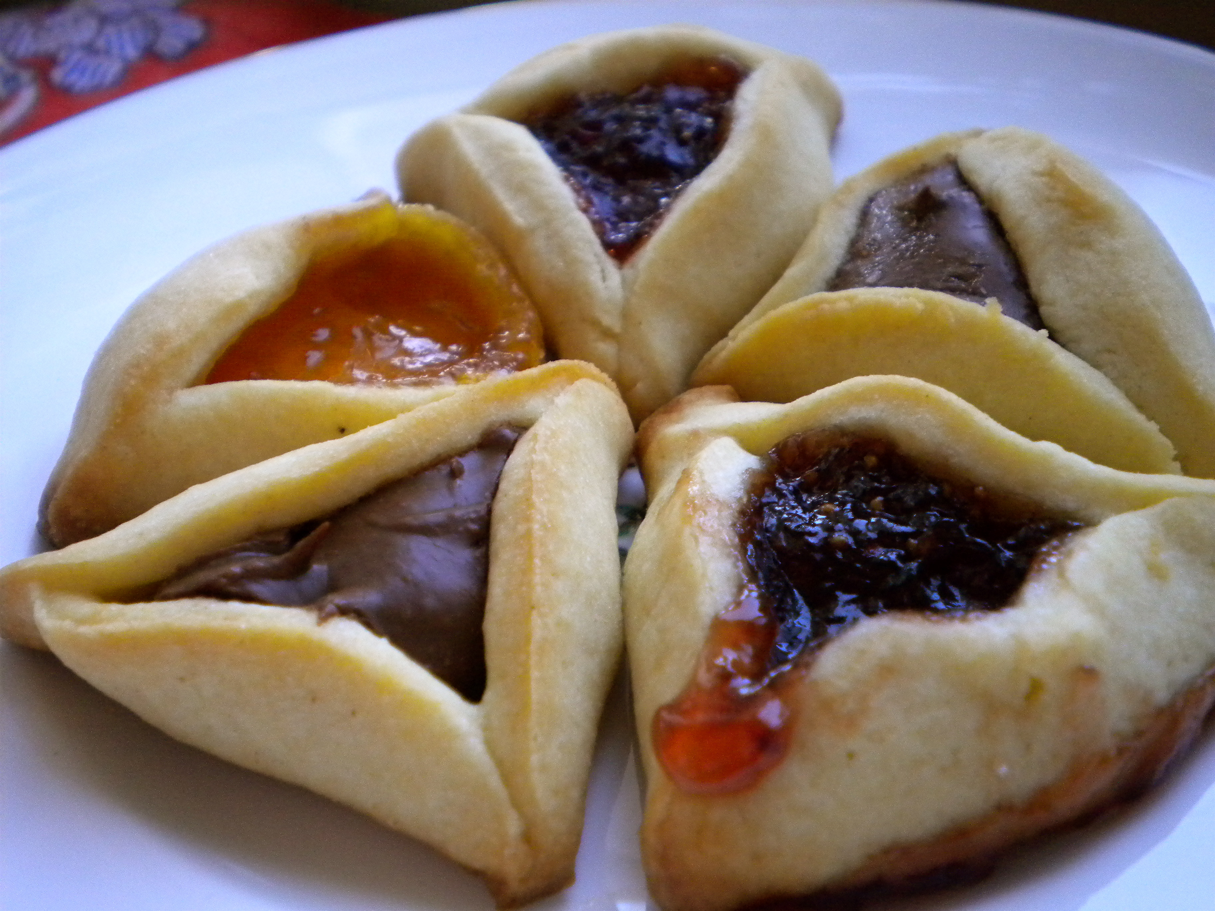

Compared to the spectacular miracles we recount on the night of Passover, the events of Purim appear unspectacular. Esther wins the beauty contest -- well, somebody had to win. Mordechai overhears a plot to kill the king -- was that a miracle? Only when you read the "whole Megilla" do you discover that each event was a hidden miracle. The very name "Megillat Esther" can mean "Revealing the Hidden." Hamantaschen hint to this hidden aspect of Purim, since the poppyseeds are hidden inside the dough.
Why poppyseeds? The Talmud states that Esther ate seeds while in the palace of Achashverosh. This enabled her to avoid non-kosher food, yet maintain a healthy appearance. Perhaps the Yiddish word "mon" alludes to this, since the Hebrew word for manna, the miraculous food which sustained the Jewish people for 40 years in the dessert, is "mon."

Sources:
Tractate Megilla 13a.
Ta'amei HaMinhagim 895.
Mishneh Brura 695:12.

Reprinted from the Purim website of OHRNET, the Ohr Somayach Torah Magazine of the Internet.

A Life Changing Purim
By Sara Esther Crispe

I couldn’t believe it. Not again. There I was, eight weeks pregnant, and I was spotting. It was light, but it was definitely blood, and it was the last thing I wanted to see.
I called my husband and told him I needed to go to the emergency room for an ultrasound. It was late at night but I just didn’t want to wait until the morning. We managed to find a babysitter and once again headed to the familiar corridor at the Bikur Cholim hospital in Jerusalem. The very same corridor where I had been told previously on two occasions that my pregnancies hadn’t made it.
So there I was, again. This time however, I had two healthy children at home which gave me the strength of knowing that maybe, just maybe, there would be good news.
I saw her straining her eyes to determine what she was seeing, or worse, maybe what she wasn’t seeing
After what seemed like an unbearably long wait, the nurse called me in and did the routine questioning. She wrote down my dates, my history, took my weight, everything. As it was so early in the pregnancy, I hadn’t yet been to my doctor, but with my history, and especially with the spotting, I knew it couldn’t wait.

The nurse did an ultrasound and kept moving the instrument over and over my stomach. I saw her straining her eyes, trying to determine what it was she was seeing, or worse, maybe what she wasn’t seeing. She then turned to me and explained that she couldn’t find the baby on the monitor. She saw the pregnancy sac but not the baby.
Having had this happen before, I knew what this meant, but she continued to explain that the ultrasound machines in the hospital weren’t the greatest resolution and since it was so early in the pregnancy that I really needed to go to my doctor and let him do an ultrasound on a better machine. I wasn’t sure if she was telling me this to make me feel better or because she really believed it, but I had no choice but to return home, unsure as to whether or not I was still pregnant.
The next morning I made an immediate appointment and came in to see the doctor. Again, I answered all the questions and it was determined that I should have been seven or eight weeks pregnant. According to my dates, the baby should have been quite visible at that point, with a strong heartbeat.
Once again, we attempted the ultrasound. Once again, there was nothing to be found. I stared alongside the doctor at the empty screen. A pregnancy sac with all the pregnancy symptoms, with no baby to be found. This time I knew it wasn’t the resolution of the monitor. Though, once again, the doctor suggested that if it would make me feel better, I could wait another week and try again. I asked if there was any point in this. If there was any chance that in a week anything would be different. He admitted that nothing would change, but that it might, just might, give me more time to come to terms with the situation.
I am not one to put off dealing with things, so to me, another week was even more difficult if not cruel. If my pregnancy was truly over, I wanted it over. I wanted to be able to mourn and move on. Dragging out the inevitable accomplished nothing other than stretching my pain.
I wanted to mourn and move on
The doctor gave me the form I needed to take to the hospital but warned me that most likely they wouldn't be able to admit me for a few days because of the holiday. It was then that I realized that the next day was Purim. And not only was Purim supposed to be a joyous occasion, but, at the time, my husband and I were running a program for post high-school students, and I was supposed to be cooking the celebratory meal for thirty-plus girls for our huge annual Purim party.
Although I had wanted to take care of this right away, I certainly had no interest in spending Purim in the hospital. I figured I would go home, get through the holiday, somehow put a smile on my face, and then deal with my loss afterwards.
When my husband asked me if I had any plans on dressing up as I had in the past, I told him I was dressed up. I was walking around laughing, smiling, friendly, happy. That wasn’t me. That wasn’t how I felt. That was my Purim mask. That upbeat attitude was masking how inside I was mourning the loss of my baby. My joy was my costume.
There is the concept that when we enter the Jewish month of Adar, we are to be marbim b’simcha, we are to increase in our joy. This is the month in which we celebrate the holiday of Purim, a time where we were witness to revealed miracles. And yet, I never knew until this incident that an obligation to be happy is not always so easy. I had always found it strange that we are commanded to be joyous. Until that year. It took all of my strength to try and find joy, it took all of my strength to try and see the positive.
I thought of how this holiday was celebrating an unbelievable turn of events
I somehow made it through that Purim. My students had a blast. I busied myself with the details of the party and getting my kids dressed up. As we read the Megillah, I reminded myself that just as G-d’s name doesn’t appear once in the whole story of Purim, and yet clearly G-d is present in every moment, so too, even though I was suffering, it was clear that I wasn’t alone. I thought of how this holiday was celebrating an unbelievable turn of events from what could have been the most devastating massacre of the Jewish people into a day of celebration and freedom.
And I thought that maybe, just maybe, this related to my situation as well. A part of me berated myself for trying to think positively when there was nothing to think about. Two ultrasounds had already said the same thing. There was no baby. My pregnancy was over. And yet, the story of Purim also seemed closed and shut and then there was a miracle.
But when Purim was over, I figured I had no other choice but to register at the hospital. And yet, they wouldn’t let me. With all of the annoyances of Israeli bureaucracy, there was a time limit for the doctor’s slip, and the time had expired. I was told that in order to come to the hospital, I would once again need to go back to my doctor and get another slip from him. And no, he could not fax it. And no, it couldn’t be a different doctor.
I realized that by the time I could get to the doctor and then to the hospital it would be Thursday, and I absolutely didn't want to spend Shabbat in the hospital. I figured I would just go on Sunday to the doctor (Sunday is a work day in Israel) and then to the hospital that evening.
It was Saturday evening as I was arranging babysitting for the next day when I heard sirens. One after the other after the other. From all directions to all directions until their wail became deafening. I knew there had been an attack. And I knew that unfortunately there must have been many casualties.
I turned on the radio to discover that a bomber had detonated himself about ten minutes away from my apartment, in the neighborhood of Beit Yisrael, alongside a group of women who were standing with their baby carriages. I would soon learn that six young children were murdered in this attack, another four mothers were killed and over fifty women and children were seriously injured.
I sat in shock trying to comprehend this immense loss. Children, who just a day ago were running around in their Purim costumes, were now gone. How quickly the world could turn upside down.
I thought to myself that even though I had lost my baby, there was no comparison to the pain and loss that these families, their loved ones and the entire Jewish people had just experienced. There was no way I was going to try to go to the hospital. The hospitals needed all their resources to focus on the victims. Anything not critical would have to wait.
I waited another week, until the next Sunday, to finally return to the doctor for my new hospital admittance slip. I explained what I needed and he began to write and then, figuring I had nothing to lose, I asked if maybe, just maybe, since I was already in the office, he would be willing to do one more ultrasound.
He explained that my blood tests had shown that my hormone levels weren't high enough, and two ultrasounds had shown that there was no baby. Another ultrasound wasn't going to change anything.
I don’t know where it came from, as I am not one to publicly show emotion, but I started to cry and cry and cry. And this doctor had no idea what to do with me. As a way of offering comfort, he asked if an ultrasound would make me feel better. And while I didn’t really think it would, I was too overwhelmed to do anything other than shake my head “yes.”
“He asked if an ultrasound would make me feel better”
I didn’t even bother lying down on the table as I wanted to see my sac one more time, clearly, and then move on. The doctor sighed as he began to move the instrument over my stomach. And then, within seconds, I was sure I saw something.
The doctor almost dropped the instrument as I asked in amazement, “Is that my baby? Is that a heartbeat?” To which all he could do was nod his head.
Once again he asked my dates, which indicated that I should have been almost ten weeks pregnant. And yet, I wasn’t. According to the ultrasound, I was only six weeks pregnant. I was at the exact time when the baby is first able to be seen in an ultrasound. In the other two ultrasounds my baby wasn’t showing, not because he wasn’t there, but because he was too small to be seen.
"If you had done this ultrasound last week, we would not have been able to see the baby. What a miracle!" was all he could say. I left the office holding tightly in my hand the original form the doctor had given me for the D&C. That slip currently sits in my son's baby book.
Our baby boy was born exactly eight months later to the very day. We named him Netanel, meaning “gift from G-d.”

Reprinted from the website of Chabad.Org

